Sana'a University

Faculty of Engineering

Mechatronics Engineering Department

Three Project of Digital Control

**Done by:**

|  |  |
| --- | --- |
| Abdulrhman Afif Abdulsamed AL-aghbari | 202073119 |
| Afnan Khaled Al-ashwal | 202073138 |
| Ibrahim Abdurraqeeb Al-khlydy | 202073007 |
| Mohammed Jalal Naji Hassan | 202073005 |
| Osama Abdullah Motea'a | 202073041 |

**Supervised by:**

Dr. Adel Rawa

Eng. Maud Alraini

**CONTENT**

1 CHAPTER 1: Project:1( Ir sensor with Arduino ) 1

1.1 Introduction 1

1.2 Objective 1

1.3 Equbment 1

1.4 Simulation 2

2 CHAPTER 2: Project:2 (3_ phase to single phase) 3

2.1 Intrduction 3

2.2 Objective 3

**2.2.1** **Equipment:** 3

**2.2.2** **Sumlation** 4

3 CHAPTER 3 : Project:3( ADC) 5

3.1 Objective: 5

3.2 Simulation 5

4 CHAPTER 4 7

4.1 Reference 7

# CHAPTER 1: Project:1( Ir sensor with Arduino )

## Introduction

The Automation has a major impact in a wide range of industries and it plays a vital role in the development of various industries. The filling task is carried out by a machine to package liquid products. In past, humans were involved in the process of production. More recently, machines have taken over production of medicines, vaccines , chemical plants, etc. Micro controllers are now majorly used in many embedded systems to perform dedicated functions. The common use of micro-controllers is to make simple logical control decisions. The automation in the bottle are facing many problems because the operations are done manually. This problem faced by

Automatic bottle filling is the simplest project that we have seen nowadays. In industries that have a project like this are PLC-based projects and it is very expensive. The price of one PLC is around 1 to 2 lakh, and it is very expensive for the general people. So we have made a project on the automatic bottle filling system using Arduino UNO. The objective of this project, automatic bottle filling system using a Arduino microcontroller.

## Objective

So we have made a project on the automatic bottle filling system using Arduino UNO. The objective of this project, automatic bottle filling system using a Arduino microcontroller.

## Equbment

1)Ir senso

2)Dc motor

3)Wire

4)12 v and 5V

## Simulation

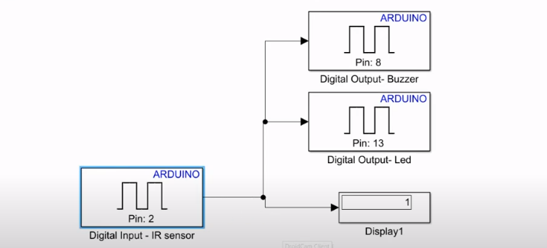

# CHAPTER 2: Project:2 (3_ phase to single phase)

## Intrduction

In small industries bottle filling operation is done manually. The manual filling operation has many shortcomings like spilling of water while filling it in bottle, equal quantity of water may not be filled, delay due to natural activities of human etc. This problem faced by small industries compels to design this system.

## Objective

. This problem faced by small industries compels to design this system.

### **Equipment:**

1. 2* DC motor (12v).
2. Scpe
3. Bridge

### **Sumlation**

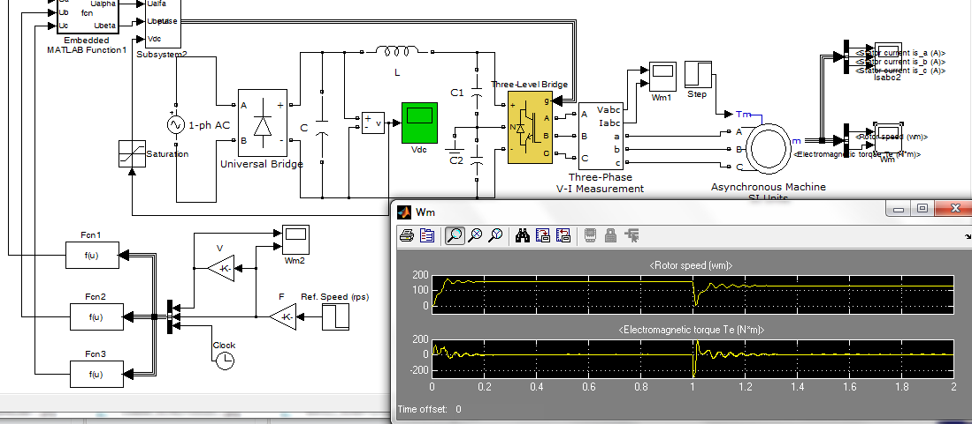

# CHAPTER 3 : Project:3( ADC)

Description: ADC is a simple Simulink model of an integrating analog to digital converter, including :  
- A counter (clock : 160MHz, size : 10 bits)  
- A resettable integrator (reset : every 2^10 160MHz clock period)  
- A comparator (input signal versus the analog ramp from the integrator)  
- A polynomial extrapolator (order : 5, calculating samples at deterministic instants from stochastic samples)

## Objective:

A counter (clock : 160MHz, size : 10 bits)  
- A resettable integrator (reset : every 2^10 160MHz clock period)  
- A comparator (input signal versus the analog ramp from the integrator)  
- A polynomial extrapolator (order : 5, calculating samples at deterministic instants from stochastic samples)

## Simulation

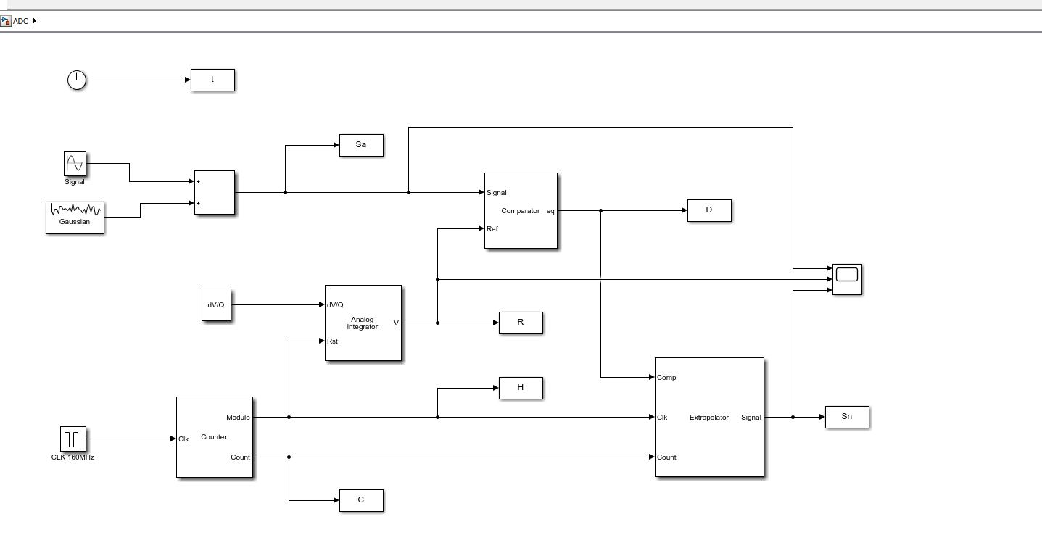

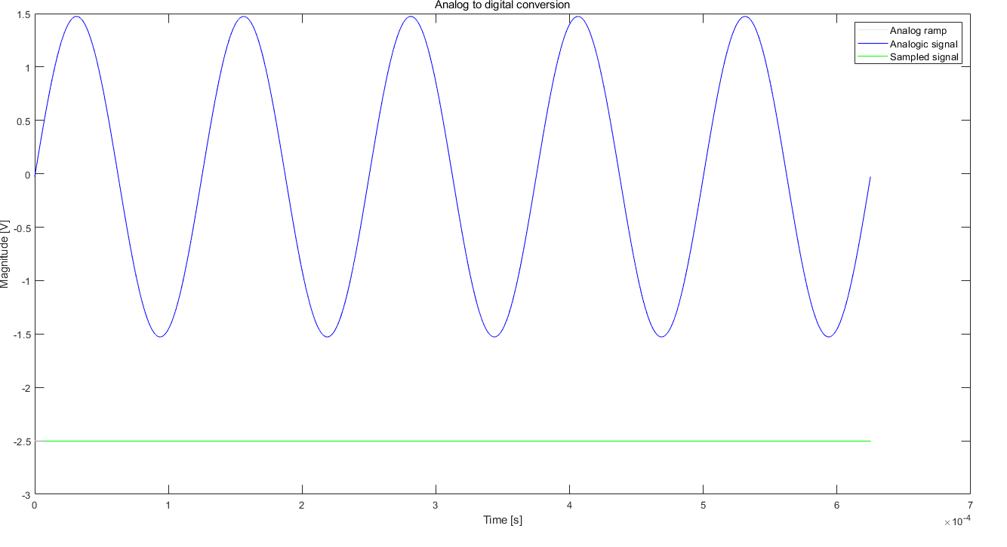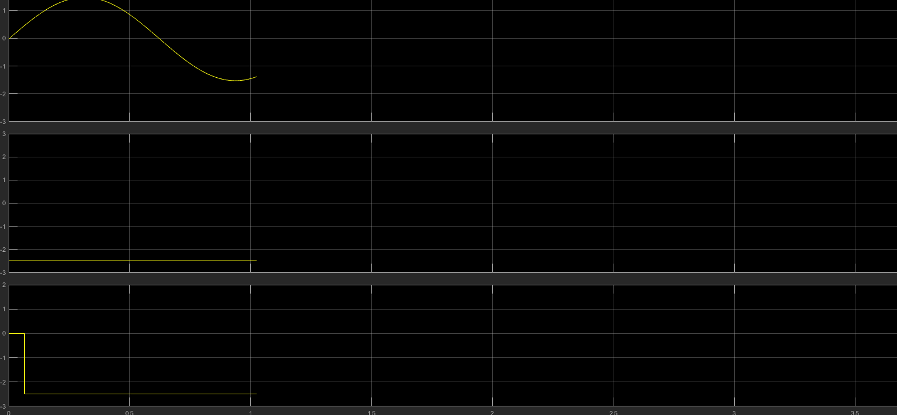

# CHAPTER 4

## Reference

[1] [Top 100+ MATLAB Simulink Projects With SLX File Open Source For Engineers (cselectricalandelectronics.com)](https://cselectricalandelectronics.com/top-100-matlab-simulink-projects-with-slx-file-for-engineers/).

[2] [ADC - File Exchange - MATLAB Central (mathworks.com)](https://in.mathworks.com/matlabcentral/fileexchange/55912-adc)